* **MODULE 2 Notes**
* **Online Portfolio**

The Electronic Portfolio is a website created by you which will house all your thoughts and reflections as you move through this course. Please continue to add to it and update it as the course moves forward. In other words, it should run concurrently with the course. This e-Portfolio is part of your final project. This website should contain your learning through the course that helps demonstrate your reflection and development. Other assignments, discussions and/or reflections will also be added to your e-Portfolio.

Use Wix, Google Sites, Wordpress

**Module 2: Discussion**

**a) Literacy - Media Arts requires the production of art works as well as theory and skills-based learning. What does it mean for a student to be "literate" in your subject area? To what extent are the conditions/principles of a literate environment reflected in the subject-specific curriculum document(s)? Look through the curriculum document and then share two examples.**

1. **Creating and Presenting:**

**Using Technologies, Tools, and Techniques:** apply traditional and emerging technologies, tools, and techniques to produce and present media art works for a variety of audiences and purposes.

A1.3 produce and refine media art works, using research, exploration, input, and reflection (e.g., research audio/visual codes and alternative media; explore new media tools, practise a range of techniques, and reflect on which tools and techniques would be appropriate for their art work; reflect on feedback from their teacher, peers, and others, and modify their preliminary work as appropriate on the basis of this feedback)

Teacher prompts: “What other media artists have used this technique? How can exploring techniques used by other media artists help you expand the range of techniques you use in your work?” “How do you decide when to integrate the input of others into your work? In what ways did feedback affect your final product?”

**2. Reflecting, Responding and Analyzing**

**B1. The Critical Analysis Process:** demonstrate an understanding of the critical analysis process by using it to monitor the creative process, and by examining, interpreting, assessing, and reflecting on media art works

B1.2use the critical analysis process to deconstruct, interpret, and assess media art works created by recognized artists, and record and organize their findings using a variety of tools and formats (e.g., identify the individual components of the work and analyse how the artist combines them to communicate a message or convey meaning; assess the effectiveness of the artist’s use of technology and tools as well as principles and elements from contributing art forms; analyse ways in which the artist has used his or her cultural background as inspiration; interpret the work to determine its intent; assess how effectively the artist addresses a social issue or communicates artistic intent; analyse the use of large-scale projection in Bill Viola’s work The Crossing)

Teacher prompt: “What was the artist’s intent in creating this artwork? How effectively does the artist communicate that intent? What specifically does he or she do to achieve that intent?”

**-Literacy definition: Literacy is the ability to read, view, write, design, speak and listen in a way that allows us to communicate effectively and to make sense of the world.**

[**What is literacy?**](https://education.qld.gov.au/parents/Documents/factsheet-l-n.pdf) **(source)**

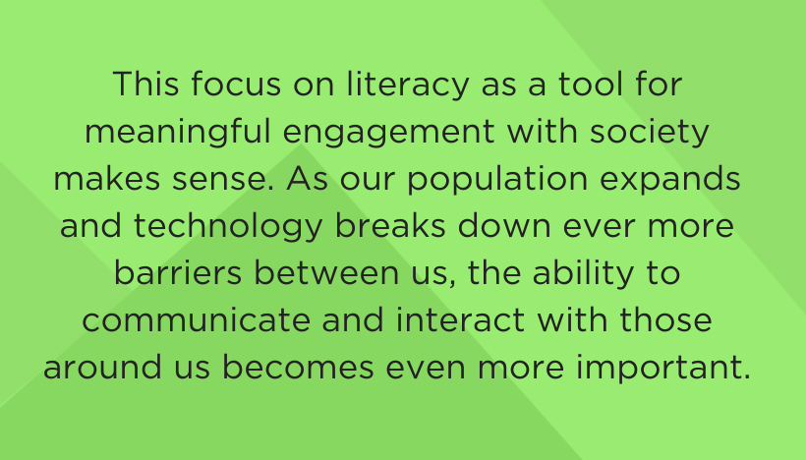

[**Literacy is More than Just Reading and Writing - National Council of Teachers of English**](https://ncte.org/blog/2020/03/literacy-just-reading-writing/)

[**Media literacy in media arts** refers to the ability to **critically analyze and understand various forms of media**, including visual arts, digital media, and multimedia presentations**1**](https://www.bing.com/ck/a?!&&p=747d4e315b486464b9c5076abcd74614464809bd2985f1e7983cce7e2d983bf2JmltdHM9MTc1MDk4MjQwMA&ptn=3&ver=2&hsh=4&fclid=0945d5ac-69e7-6259-0d51-c3a768226383&u=a1aHR0cHM6Ly9qZXJ3b29kdmlzdWFsYXJ0cy5vcmcvYXJ0LWVkdWNhdGlvbi1hbmQtbWV0aG9kb2xvZ2llcy1nbG9zc2FyeS9tZWRpYS1saXRlcmFjeS1pbi1hcnQtZWR1Y2F0aW9uLw&ntb=1). [It involves interpreting and creating art through different mediums, such as photography, film, and graphic design**1**](https://www.bing.com/ck/a?!&&p=747d4e315b486464b9c5076abcd74614464809bd2985f1e7983cce7e2d983bf2JmltdHM9MTc1MDk4MjQwMA&ptn=3&ver=2&hsh=4&fclid=0945d5ac-69e7-6259-0d51-c3a768226383&u=a1aHR0cHM6Ly9qZXJ3b29kdmlzdWFsYXJ0cy5vcmcvYXJ0LWVkdWNhdGlvbi1hbmQtbWV0aG9kb2xvZ2llcy1nbG9zc2FyeS9tZWRpYS1saXRlcmFjeS1pbi1hcnQtZWR1Y2F0aW9uLw&ntb=1).

[Bing Videos:](https://www.bing.com/videos/riverview/relatedvideo?&q=media+literacy+ppt&qpvt=media+literacy+ppt&mid=6C08192695C71555B41B6C08192695C71555B41B&mmscn=mtsc&aps=5&FORM=VRDGAR) **Introduction to Media Literacy: Crash Course Media Literacy #1**

[YouTube/](https://www.youtube.com/watch?v=AD7N-1Mj-DU) CrashCourse/ 1.2M views/ Feb. 27, 2018

Ability to Access, Anayse, Evaluate, Create and Act using all forms of communication. (see notes)

-literate in use of new and emerging/traditional tools used in school/industry

-literate in foundational vocabulary and theories

-literate in processes such as creative process/ strands/principles of media

-literate in career path choices and what education skills are needed to get there

-literate in the steps of the creative process

-literate in the elements of art and principles of media design (hybridization, interactivity, point-of-view, duration)

-literate in terms of the steps required to research and attain their goals in terms of processes required in using technology and tools.

-knowing how to communicate their purpose and artistic intent

Reflecting analysing, etc- demonstrate an understanding of the critical analysis process by using it to monitor the creative process, and by examining, interpreting, assessing, and reflecting on media art works;

Identity and Values: demonstrate an understanding of how media art works to reflect personal and cultural identity, and affect personal, cultural, and community values and their awareness of those values.

Foundations- Terminology: demonstrate an understanding of, and use correct terminology when referring to, elements, principles, and other concepts relating to media arts;

Contexts and Influences: demonstrate an understanding of the sociocultural and historical contexts of media arts;

Responsible Practices: demonstrate an understanding of responsible practices associated with producing, presenting, and experiencing media art works.

\***Choose one of the models-define and create an example of how it can be used in the classroom ie- Instructional Design Models, Theories & Methodology:**

# Merrill's First Principles of Instruction

"A learner’s experience should center around solving a problem and should involve four phases."

**Phases / Components of Merrill's First Principles of Instruction**

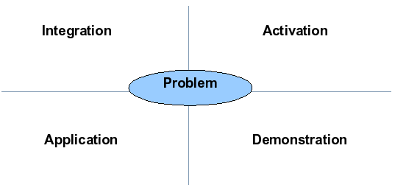

Source:  
[<http://edutechwiki.unige.ch/en/First_principles_of_instruction>]

**Pebble-in-the-Pond:**  
Merrill uses the following diagrams below to illustrate what he calls the "pebble-in-the-pond" approach to design. This assumes that the "First Principles" are kept in mind and the first "pebble" starts the design, and learners are then overcome each problem at a time before moving on to the next.

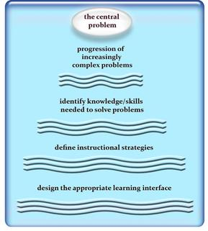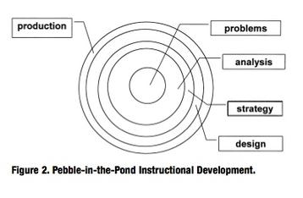

Source:[<http://instructionaldesignfusions.wordpress.com/2010/08/29/merrills-pebble-in-the-pond-approach-to-isd/>

[Merrill's First Principles of Instruction-Instructional Design Models, Theories & Methodology](https://k3hamilton.com/LTech/merrill.html)

**b) Motivation - List one major area that you find your students lack, in regard to knowledge, with respect to Media. Propose one idea that you could organize in your classroom that would motivate students to become more interested in developing those particular gaps. Brainstorm innovative ideas for programs that would 'hook' and secure students' attention and generate excitement for learning in this area.**

* **Discussion**

Media Arts requires the production of art works as well as theory and skills-based learning. Look through the subject specific Curriculum documents in Media Arts (Grades 11 & 12). Using the discussion forum: **What goals would you set in terms of the curriculum content? Align these goals with the essential concepts that are required, in your opinion, for learning in the media arts course. Are the goals and concepts consistent across the grades? What does it mean for a student to be "literate" in the media arts? To what extent are the conditions/principles of a literate environment reflected in the subject-specific curriculum document(s)?**

**Student areas of lacking knowledge:**

**-how to take proper photographs that show character and emotion.**

**-how to use PS to create interesting digital compositions**

**-painting with pixels**

**-using video editing tools and understanding the importance of ‘mis en scene’ in compositions.**

**-privacy and copyright concerns**

Post Your Response to the [Discussion](https://brightspace.uwindsor.ca/d2l/common/dialogs/quickLink/quickLink.d2l?ou=199847&type=discuss&rcode=74b39629d1124cf4a6880070-27) Board.

* **Reflection**

As you read these, in front of each point ask yourself - "Do/Are my practices...?"

-Fair, transparent, and equitable for all students

-Support all students, including those with special education needs, those who are learning the language of instruction (English or French), and those who are First Nation, Métis, or Inuit

-Carefully planned to relate to the curriculum expectations and learning goals and, as much as possible, to the interests, learning styles and preferences, needs, and experiences of all students

-Communicated clearly to students and parents at the beginning of the school year or course and at other appropriate points throughout the school year or course

-Ongoing, varied in nature, and administered over a period of time to provide multiple opportunities for students to demonstrate the full range of their learning

-Provide ongoing descriptive feedback that is clear, specific, meaningful, and timely to support improved learning and achievement

-Develop students’ self-assessment skills to enable them to assess their own learning, set specific goals, and plan next steps for their learning (*Growing Success* [document](https://www.edu.gov.on.ca/eng/policyfunding/growsuccess.pdf) 12).

-Develop strategies for teaching media arts in the context of a media arts class while considering and contextualizing how the topic affects ELL learners; IEP learners; Culturally and/or Religiously diverse learners; and First Nations/Metis/Inuit learners.

* **Media Arts Curriculum**

Senior Media Arts courses focus on the students’ use of multiple media and their skills in the use of both traditional and emerging technologies and tools. There are three distinct strands and four organizing principles in the Media Arts curriculum (pp. 121-122).

**Strands:**

* 1. Creating and Presenting
  2. Reflecting, Responding and Analysing
  3. Foundations

**Organizing Principles:**

* + 1. Hybridization
    2. Interactivity
    3. Duration
    4. Point of View

These should be incorporated throughout all media arts courses. It is crucial to familiarize yourself with them.

*The Ontario Curriculum,* *Grades 11 and 12 - The Arts* (2010)

* **Supporting All Learners**

It is vital to locate resources that enhance programming. The sharing of resources and best practices benefits educators and students. In the *Arts Curriculum* (2010), there are special considerations for Program Planning in the Arts which may include students with special needs, students requiring accommodations for modifications, English Language Learners, Culturally or Religiously Diverse Learners and First Nations/Metis/Inuit Learners. (pp. 31-36, 38-40). Given the cross-disciplinary nature of Media Arts and the increasingly diverse student population in Canada, explore the following websites.

*Learning for All* (2013), Ontario Ministry of Education [website](https://www.ontario.ca/page/learning-all-guide-effective-assessment-and-instruction-all-students-kindergarten-grade-12)

Our Shared Beliefs • All students can succeed. • Each student has his or her own unique patterns of learning. • Successful instructional practices are founded on evidence-based research, tempered by experience. • Universal design and differentiated instruction are effective and interconnected means of meeting the learning or productivity needs of any group of students. • Classroom teachers are the key educators for a student’s literacy and numeracy development. • Classroom teachers need the support of the larger community to create a learning environment that supports all students. • Fairness is not sameness. (Adapted from Education for All, K–6, pp. 4–5.)

Three elements – personalization, precision, and professional learning – are critical to the process.4 Personalization – Education that puts the learner at the centre, providing assessment and instruction that are tailored to students’ particular learning and motivational needs. Precision – A system that links “assessment for learning” to evidence-informed instruction on a daily basis, in the service of providing instruction that is precise to the level of readiness and the learning needs of the individual student. Professional learning – Focused, ongoing learning for every educator “in context”, to link new conceptions of instructional practice with assessment of student learning. An education system in which these components are closely interconnected can successfully address the need to “establish classroom routines and practices that represent personalized, ongoing ‘data-driven, focused instruction’”. (Fullan et al., 2006, pp.16–26, 87)

EduGains Differentiate Instruction [website](https://www.edugains.ca/newsite/di/index.html)

Arts Integration and Differentiated Instruction article & [website](https://www.kennedy-center.org/education/resources-for-educators/classroom-resources/articles-and-how-tos/articles/collections/arts-integration-resources/arts-integration-and-differentiated-instruction/)

* **Discussion**

Motivation - List one major area that you find your students lack, in regards to knowledge, with respect to media &/or Media Arts. Propose one idea that you could organize in your classroom that would motivate students to become more interested in developing those particular gaps. Brainstorm innovative ideas for programs that would 'hook' and secure students' attention and generate excitement for learning in this area.

Post Your Response in the [Discussion](https://brightspace.uwindsor.ca/d2l/common/dialogs/quickLink/quickLink.d2l?ou=199847&type=discuss&rcode=74b39629d1124cf4a6880070-27) Board.

* **Theories**

One crucial part is the application and inclusion of various theories in media arts courses. One key pedagogical approach is “constructivism” developed by Jean Piaget in the 1930s. Lev Vygotsky is considered the ‘father’ of “social constructivism.” Learning is a social process where learners gain knowledge through interactions and then construct meaning. Various theories can be applied to effectively teach adolescents the discipline of media arts. Some include Erik Erikson’s Psychosocial Development, Bloom’s Taxonomy, Merrill’s First Principles, Howard Gardner’s Multiple Intelligences, and SAMR.

Instructional Design Models, Theories & Methodology Website [website](https://k3hamilton.com/LTech/merrill.html)

“A Constructivist Approach to Teaching of Media Studies Using Google Drive” (2017) [link](https://jitp.commons.gc.cuny.edu/a-constructivist-approach-to-teaching-media-studies-using-google-drive/)

A Quick Guide to Four Instructional Design Models [website](https://www.shiftelearning.com/blog/top-instructional-design-models-explained)

Erik Erikson’s 8 Stages of Development (2017) [video](https://www.youtube.com/watch?v=aYCBdZLCDBQ)

Bloom’s Taxonomy for Learning [website](https://uwaterloo.ca/centre-for-teaching-excellence/catalogs/tip-sheets/blooms-taxonomy)

Bloom’s Taxonomy: Why, How, & Top Examples [video](https://www.youtube.com/watch?v=OOy3m02uEaE)

Merrill’s Principles by M. David Merrill website

<https://elearningindustry.com/merrills-principles-instruction-definitive-guide>

Gardner’s Multiple Intelligences [website](https://www.simplypsychology.org/multiple-intelligences.html)

SAMR MODEL [website](https://www.powerschool.com/blog/samr-model-a-practical-guide-for-k-12-classroom-technology-integration/)

SAMR Video [link](https://www.commonsense.org/education/videos/introduction-to-the-samr-model)